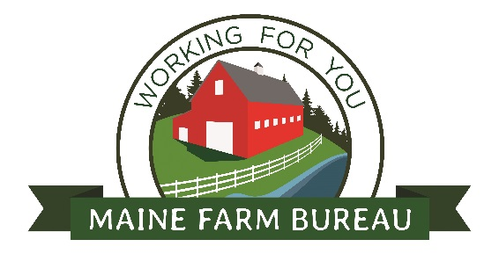
Maine Farm Bureau’s 65th Annual Meeting

Black Bear Inn
4 Godfrey Dr., Orono, ME 04473
Saturday, November 19th and Sunday, November 20th

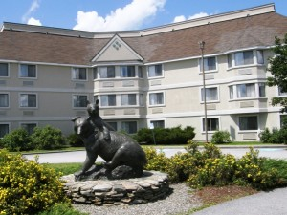
Penobscot County Farm Bureau is proud to host Maine Farm Bureau’s 65th Annual Meeting. This year will be filled with a range of guest speakers on topics like the Food Safety Modernization Act (F.S.M.A.), Estate Planning, Maine FARMS program, and exploring the benefits of solar.
The guest speaker’s event is open to the public, so spread the word to those you think might benefit from these sessions.
Following the morning speaker sessions, there will be farm tours in Exeter, Maine. During the tours, you will see an envelope potato house, an optical sorter, a methane digester, a robotic dairy feeder and more!

Saturday night, November 19th, a banquet dinner will take place with entertainment by the acapella group, Mainely Voices. The cost of the banquet is $30.00 per person. Please make reservations with the Maine Farm Bureau office by November 6th. You can make reservations by calling 207-622-4111 or by email Lena Sirois at lsirois@mainefarmbureau.com.

Sunday, November 20th, the general and voting delegate’s session will take place. Maine Farm Bureau’s policies are set, not by its director or board, but originated by members at the county level and brought for discussion and a vote at the annual meeting. Come join us to see the process of how we set the direction of the organization for the next year.

Rooms are available at $97.01 a night with tax included. The rooms can be booked by calling 207-866-7120 and by using the group code, MFB.

Hope to see you all at the meeting.

Sincerely,

Aaron Perkins, President
Penobscot County Farm Bureau

Maine Farm Bureau’s 65th State Annual Meeting
Saturday, November 19th

8:00 am – 9:00 am Food Safety Modernization Act (F.S.M.A.) Room A
Linda Titus, AgMatters LLC

8:00 am – 9:00 am Current-Use Property Taxation Options: Room B
Tree Growth & Farmland
Stephany Gilbert & Andy Shulz
Dept. of Ag., Conservation & Forestry

9:00 am – 9:30 am Farm Protection Room A
Farm Family Insurance

9:00 am – 9:30 am Maine FARMS Program Room B
Ashley Sears, Dept. of Ag., Conservation & Forestry

9:30 am – 10:00 am Forage in a Changing Climate Room A
Dr. Richard Kersbergen, University of Maine

9:30 am – 10:00 am New and Emerging Pests Room B
Lauchlin Titus, AgMatters LLC

10:00 am – 11:00 am Solar for the Community Room A
James Maneer, ReVision Energy

10:00 am- 11:00 am Soil Fertility & Weed Management Room B
Dr. David Handley, University of Maine

11:00 am – 12:00 pm Estate Planning Room A
Ethan Robertson, Farm Credit East

11:00 am – 12:00 pm Vegetable Production Room B
Dr. Mark Hutton, University of Maine

12:00 pm – 1:00 pm Lunch & Speaker Gary Keough, New England Ag. Statistic - USDA

1:00 pm – 5:00 pm Farm Tours
- Crane Brothers Farms
- Stonyvale Farms

6:00 pm – 7:00 pm Open Resolutions followed by dinner buffet & dessert ($30.00 per meal)

7:00 pm Mainely Voices

Maine Farm Bureau’s 65th State Annual Meeting
Sunday, November 20th

8: 00 am – 8:30 am Breakfast

8:30 am - 9:30 am General Session
- David Doak - MFB President’s Report
- Treasurer's Report – Bruce Bell
- Executive Director’s Report – Dr. Alicyn Smart
- Credential Committee

9:30 am – 12:00 pm Voting Delegates Session
12:00 pm – 1:00 pm Lunch
1:00 pm Voting Delegates Session resumes (if needed)

TBD Brief State Board of Directors Meeting

